**Kubernetes installation (Master and Nodes)**

**Search in google and follow the steps one by one.**

* Install kubeadm
* [container runtimes](https://kubernetes.io/docs/setup/production-environment/container-runtimes/)
* Docker runtime
* [Install Docker Engine](https://docs.docker.com/engine/install/#server)
* Ubuntu operating system

Step:1

Uninstall old versions

sudo apt-get remove docker docker-engine docker.io containerd runc

Step:2

#### Set up the repository

Update

sudo apt-get update

### Install

sudo apt-get install \

apt-transport-https \

ca-certificates \

curl \

gnupg \

lsb-release

Step:3

Add Docker’s official GPG key:

curl -fsSL https://download.docker.com/linux/ubuntu/gpg | sudo gpg --dearmor -o /usr/share/keyrings/docker-archive-keyring.gpg

Step:4

Use the following command to set up the **stable** repository:

echo \

"deb [arch=amd64 signed-by=/usr/share/keyrings/docker-archive-keyring.gpg] https://download.docker.com/linux/ubuntu \

$(lsb_release -cs) stable" | sudo tee /etc/apt/sources.list.d/docker.list > /dev/null

Step:5

*Install Docker Engine:*

sudo apt-get update

sudo apt-get install docker-ce docker-ce-cli containerd.io

Step:6

Create a directory

sudo mkdir /etc/docker

Create a file

cat <<EOF | sudo tee /etc/docker/daemon.json

{

"exec-opts": ["native.cgroupdriver=systemd"],

"log-driver": "json-file",

"log-opts": {

"max-size": "100m"

},

"storage-driver": "overlay2"

}

EOF

Step:7

Restart Docker and enable on boot:

sudo systemctl enable docker

sudo systemctl daemon-reload

sudo systemctl restart docker

Step:8

Verify docker by using command

Docker ps

Step:9

## *Installing kubeadm, kubelet and kubectl*

Update the apt package index and install packages needed to use the Kubernetes apt repository:

sudo apt-get update

sudo apt-get install -y apt-transport-https ca-certificates curl

Step:10

Download the Google Cloud public signing key:

sudo curl -fsSLo /usr/share/keyrings/kubernetes-archive-keyring.gpg <https://packages.cloud.google.com/apt/doc/apt-key.gpg>

Step:11

Add the Kubernetes apt repository:

echo "deb [signed-by=/usr/share/keyrings/kubernetes-archive-keyring.gpg] https://apt.kubernetes.io/ kubernetes-xenial main" | sudo tee /etc/apt/sources.list.d/kubernetes.list

Step:12

Update apt package index, install kubelet, kubeadm and kubectl, and pin their version:

sudo apt-get update

sudo apt-get install -y kubelet kubeadm kubectl

sudo apt-mark hold kubelet kubeadm kubectl

Step:13

In master node only:

Command for master only: Kubeadm init

Step:14

Copy document

*Ex:*

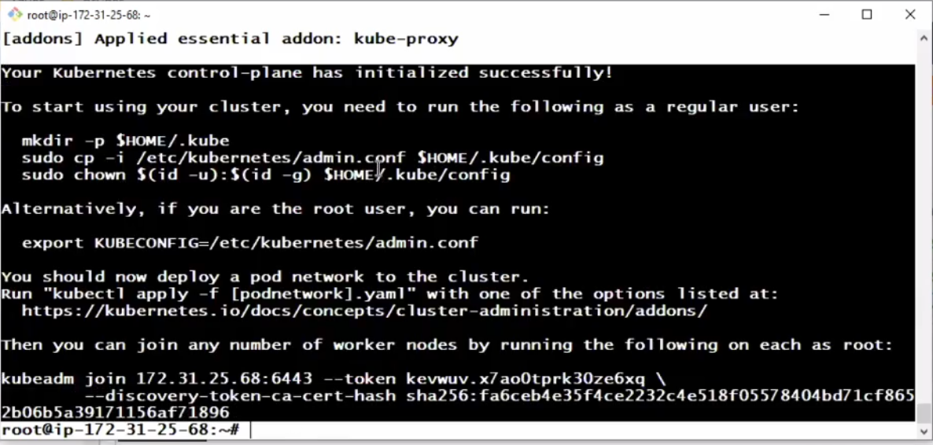

Step:14

Copy the document and past it in notepad.

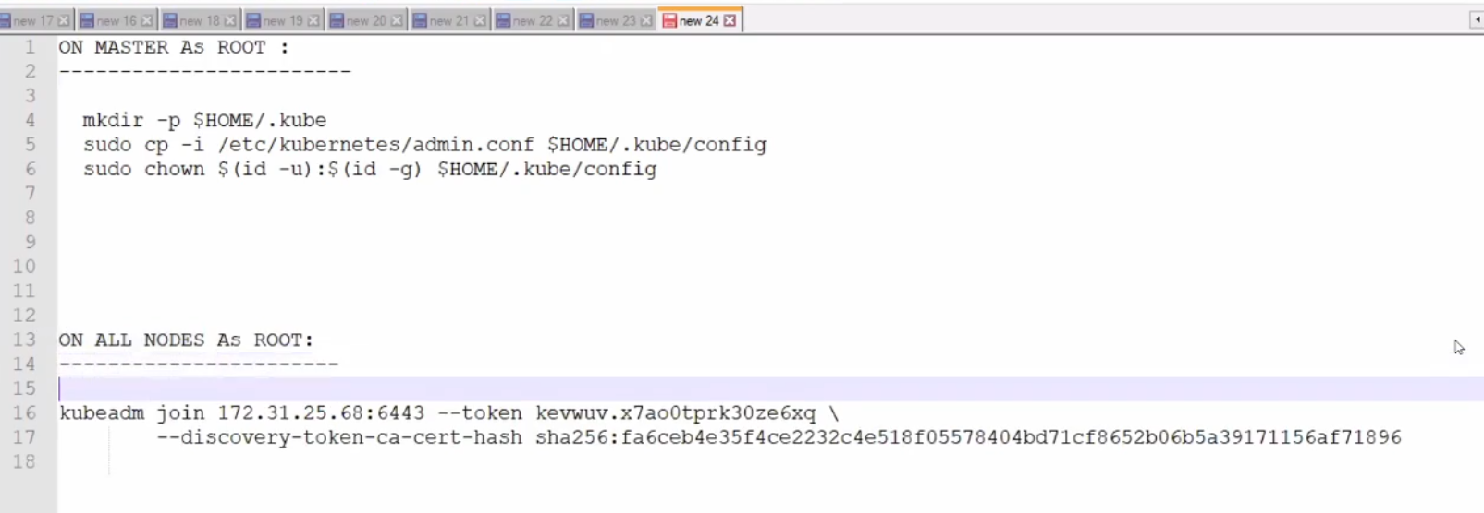

Step:15

Copy the commands one by one on master side only.

*Example:*

### 

Step:16

Copy the command on node side only.

*Example:*

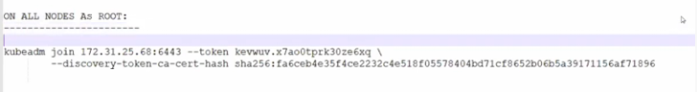

Step:17

On master as root:

# kubectl apply -f "https://cloud.weave.works/k8s/net?k8s-version=$(kubectl version | base64 | tr -d '\n')"

Successfully K8s (master and nodes) installation completed.